Name: | ___________________________________________________ |  |  |  | Date: ___________
 | Year 8 Mathematics 2015  Test 3: General and Extension  Topics – Volume Fractions Decimals Percentages
Total Time: | 56 minutes
Total Reading: | 4 minutes
Total Working: | 52 minutes
Weighting: | % of the year.
CALCULATOR FREE

Time: | minutes | Marks for Section 1: |  | 32
Reading: | 2 minutes | Equipment Allowed: |  | 1 A4 page of notes
Working: | 28 minutes

________
59

= %

1. What fraction of the circle is green?
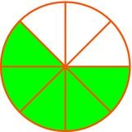
A B C D
2. What decimal fraction is represented by the yellow part of the rectangle?

A 0.2 B 0.4 C 0.5 D 0.6
3. Write in simplest form.
A B C D
4. Which of the following is an improper fraction?
A B C D

5. Write as an improper fraction.
A B C D

6. Write as a simplified mixed fraction.
A B C D
7. Write 0.36 as a simplified fraction.
A B C D
8. Change to a decimal.
A 2.58 B 2.85 C 2.625 D 2.225
9. Change to a decimal.
A 0.56 B 0.83 C $0.5\dot{3}$ D $0.8\dot{3}$

10. What is the value of ?
A 4 B 5 C 12 D 18
11. What is a half of a half?
A $\frac{1}{2}$ B $\frac{1}{4}$ C $\frac{2}{2}$ D $\frac{1}{8}$
12. Find .
A B C D
13. Find .
A B C D

14. Work out in your head.
A B C 8 D 24
15. Work out in your head.
A B C D
16. 25.073 ÷ 100 =
A 0.025 073 B 0.250 73
C 2507.3 D 25 073
17. Estimate an answer to
A 2 B –1 C –2 D –3
18. Which of these would give you the most money?
A of $690 B of $500
C of $972 D of $480
19 . Find of 42.
A 14 B 18 C 21 D 28
20. What is 2% of 3000

A 0.6 B 6 C 60 D 600
Calculator Free continued

21. (1 mark)
of a 20.7 ha paddock is no good for planting. How many hectares can be planted?

22 (3 marks) Calculate each of the following

a. $\frac{2}{8}+ \frac{3}{8}$

b. $\frac{2}{3}× \frac{3}{5}$

c. $\frac{4}{7}÷ \frac{2}{5}$

23. (8 marks) Calculate each of the following. (show full working)

a

b

c

d

CALCULATOR ALLOWED
Time: | 20 minutes | Marks for Section 2: | 27
Reading: | 2 minutes | Equipment Allowed: | 1 A4 page of notes  Calculator
Working: | 24 minutes
Name: __________________________________

24.
Represent each of the following intervals on a number line. 4 marks (2,2)
a $x>-1.5$

b $-2\frac{3}{4}<x≤1\frac{2}{3}$

25 .Insert <, =, or > to make true statements. 5 marks (1,1,1,1,1)
a

b

c

d

e

26 What fraction of an hour is 24 minutes?(1 mark)

27 What percentage of an hour is 15 minutes? ( 1 mark)

28 (2 marks) Write in order from smallest to largest:
, 0.26, -0.27, ,
__________________________________________

29 (6 marks) Fill in the missing spaces to make each row full of equivalent values

Decimal | Percentage | Fraction
0.45 | 45% | $$\frac{9}{20}$$
 | 30%
0.03
 |  | $$\frac{2}{5}$$

30. If $200 is increased by 15% and then decreased by 10% how much money remains. (2marks)
31. (3 Marks)

Micaela is saving up to buy a unicorn. Her parents offer to give her an extra 10% of any money she saves. She earns the following amounts $415.50 , $1270, $1820.55 and saves all of it.

a. How much has she saved?

b. How much will her parents give her?

c. How much will she have in total to but a unicorn?

32 . (3marks)
What is volume of the triangular prism below? AB = 3 m, BC = 4 m, AC = 5 m and AD = 16 m.

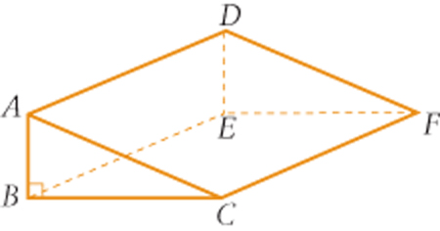

END OF SECTION TWO

